1.

**SELECT last_name, first_name, SUM(amount) AS betaald**

**FROM customer**

**LEFT JOIN payment ON customer.customer_id = payment.customer_id**

**GROUP BY customer_id**

**ORDER BY last_name, first_name**

2.

**SELECT city.city, SUM(payment.amount) AS totaal**

**FROM customer**

**INNER JOIN payment ON customer.customer_id = payment.customer_id**

**INNER JOIN address ON customer.address_id = address.address_id**

**INNER JOIN city ON address.city_id = city.city_id**

**GROUP BY city.city_id**

**ORDER BY city.city**

3.

**SELECT customer.first_name, customer.last_name, film.title, rental_date, return_date**

**FROM rental**

**INNER JOIN inventory ON rental.inventory_id = inventory.inventory_id**

**INNER JOIN film ON inventory.film_id = film.film_id**

**INNER JOIN customer ON rental.customer_id = customer.customer_id**

**WHERE rental_date >= '2005-06-01'**

**AND rental_date < '2005-07-01'**

4.

**UPDATE country SET last_update = "2018-12-04 14:05:00"**

**of**

**UPDATE country SET last_update = CONCAT( CURDATE(), " ", "14:05:00" )**

5.

**CREATE TABLE sakila.actor_backup**

**(**

**actor_id smallint(5) unsigned auto_increment primary key,**

**first_name varchar(45) not null,**

**last_name varchar(45) not null,**

**last_update timestamp**

**);**

**INSERT INTO actor_backup**

**SELECT * FROM actor ;**

6.

**INSERT INTO actor (first_name, last_name) VALUES ("MATIAS", "SCHOENAERTS")**

7.

**SELECT * FROM actor WHERE last_name = "SCHOENAERTS"**

ID = 201 (normaal gezien)

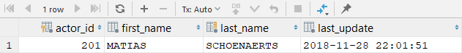

8.

**INSERT INTO actor SET first_name = "MATIAS", last_name = "SCHOENAERTS"**

9.

**UPDATE actor SET first_name = "MATTHIAS" WHERE actor_id > 200**

Controle:

**SELECT * FROM actor WHERE actor_id=201**

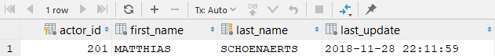

10.

**DELETE FROM actor WHERE actor_id BETWEEN 201 AND 202**

Controles:

**SELECT * FROM actor WHERE actor_id >= 201**

**SELECT * FROM actor WHERE last_name = "SCHOENAERTS"**

**SELECT * FROM actor WHERE last_name LIKE "%SCHOEN%"**

**…**